1. **HOME PAGE**

1. **Login / Registration**

Use demo account:

Email: [admin@phtv.com](mailto:admin@phtv.com)

Password: admin

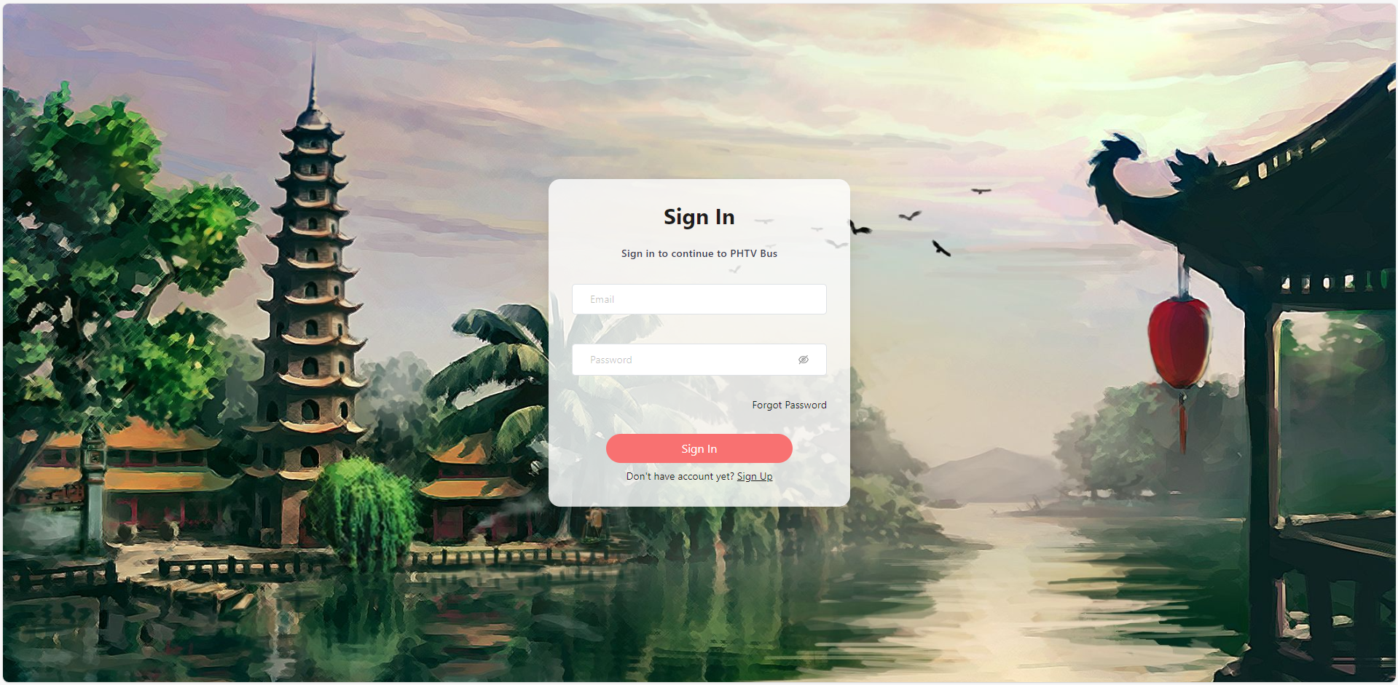

1. **Find schedule:**

1. **Search and filter schedule:**

1. **Seat selection:**

1. **Payment:**

1. **Get ticket:**

1. **Go to Admin/ Profile page:**

1. **Admin Page:**

1. **Profile Page:**

